Github account : <https://github.com/ChhornKakada/InternetProgramming.I4/tree/main/tp3.Local%20storage%2C%20Cookie%20and%20Session/>

# To-Do list with Local storage

* 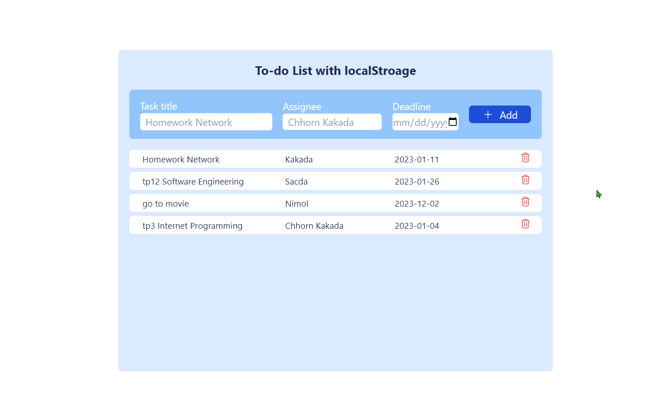index.html
* app.js

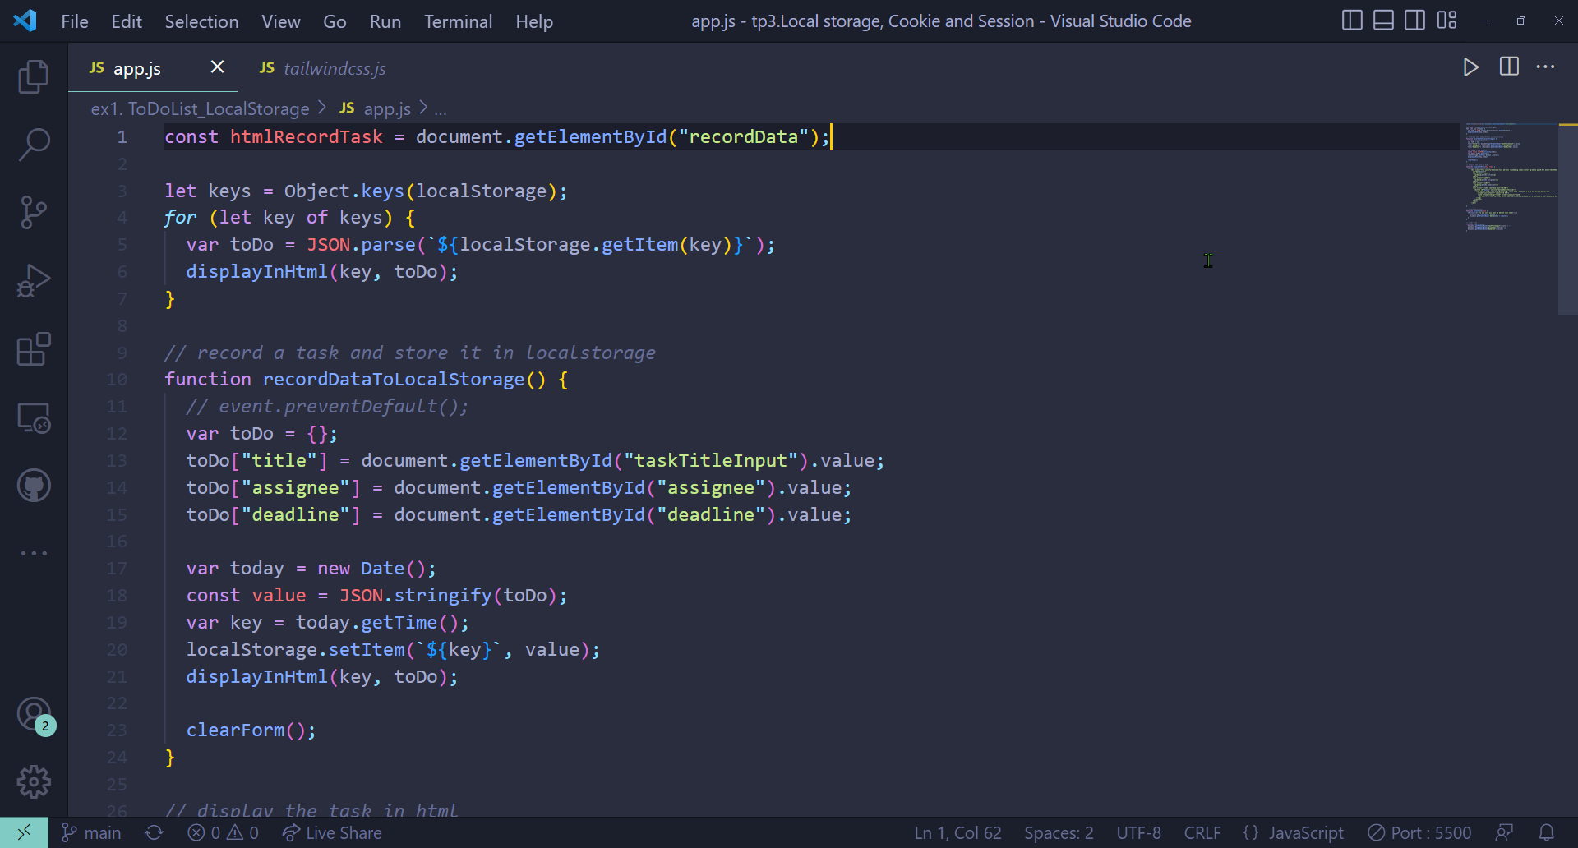

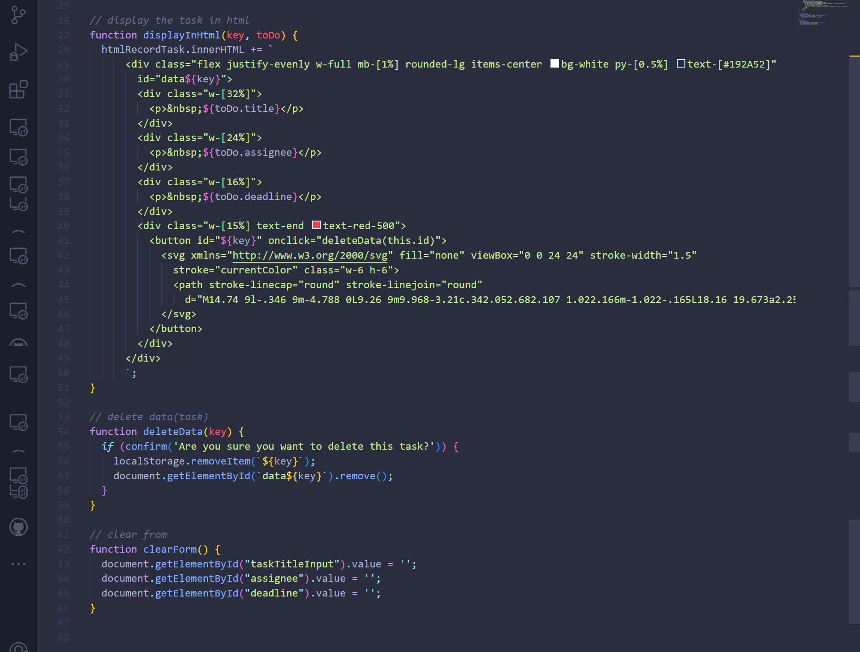

# To-Do list with Session Storage

1. 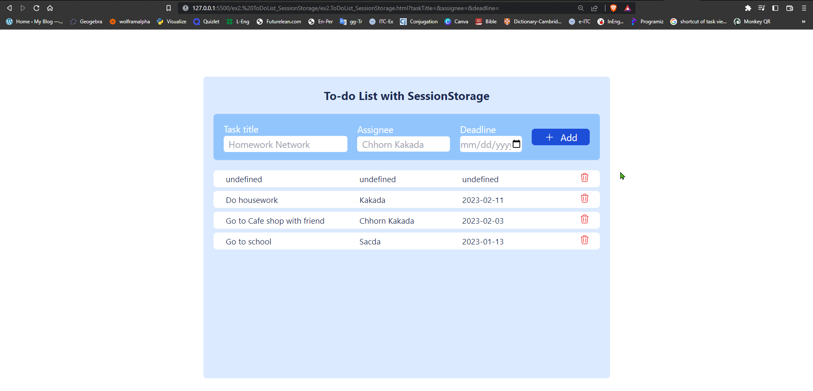index.html
2. 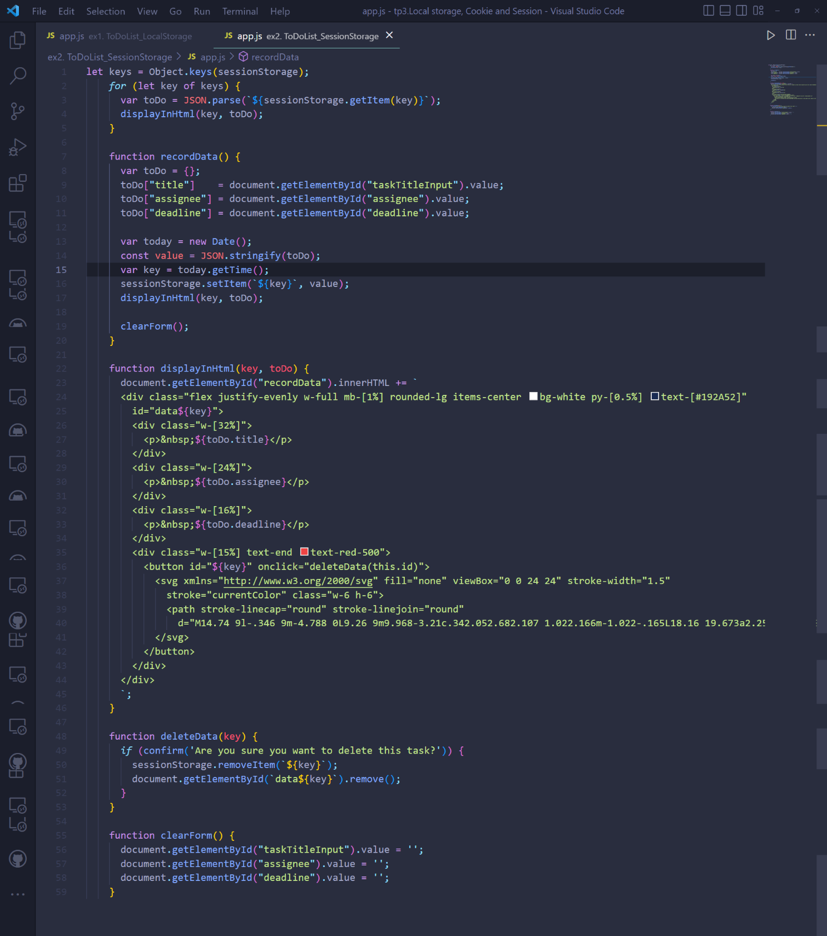app.js